# 25156 TSAMBA Huberthe Marthina

# Individual Assignment I: PL/SQL Window Functions Mastery Project

Step1: Problem definition

Define a specific, measurable business scenario (in t2000 market)

**1.Business Context**:  
T2000 Market is a supermarket located in the city that sells some household items, food, electronics, and accessories. They have online sales with home delivery. They’ve many branches in the country and have customers services.

2.Data challenge: It is difficult to satisfy the entire clientele. The demands are too great, there is a lack of modernity in the products with prices that are often too high and not accessible to all levels of income.

3. Expected Outcome: To evaluate product sales by sector and by semester, track cumulative monthly figures, analyze monthly trends, and use 3-month moving averages to improve the accuracy of forecasts.

Step2: Success criteria

1. Top 5 products per region/quarter → RANK()

**Tables:** Sales, Branch, Product

* 1. Sales provides the sales data.
  2. Branch identifies the branch.
  3. Product identifies the product category.
  4. RANK() to rank products per branch per quarter.

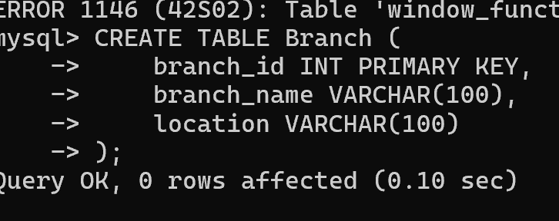

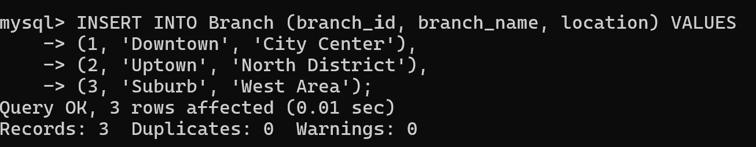

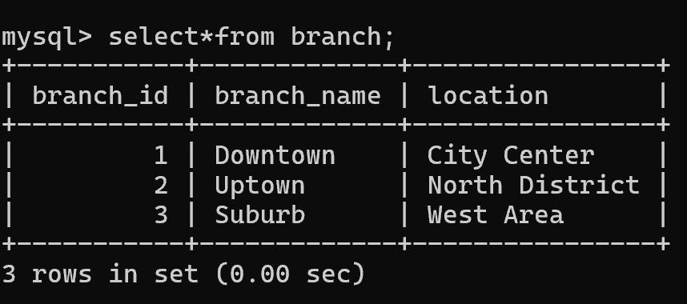

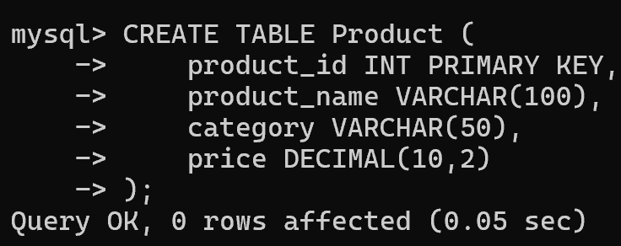

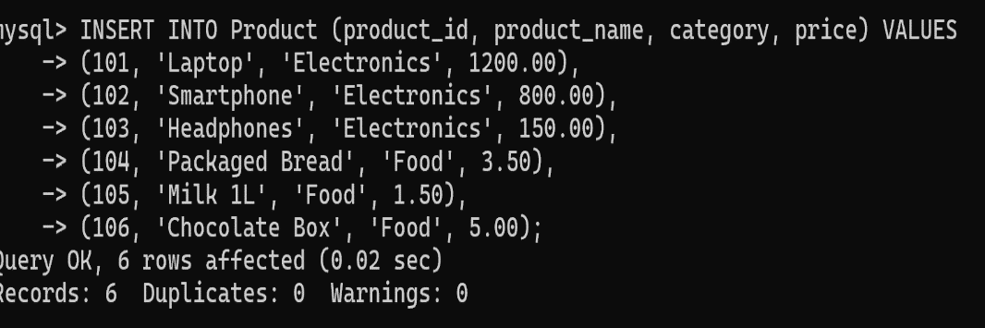

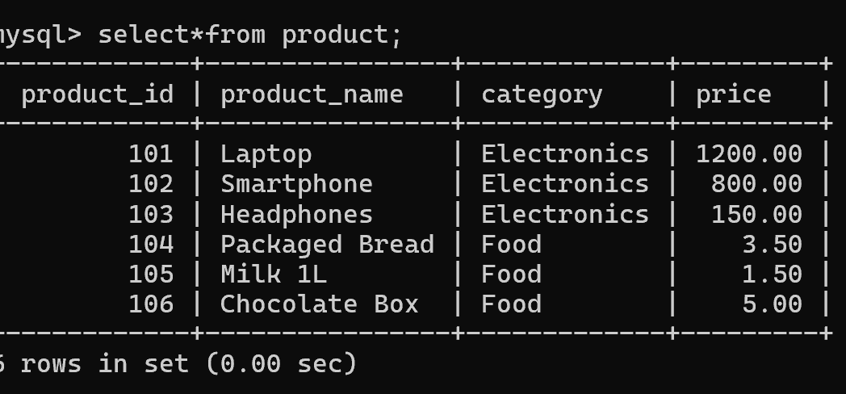

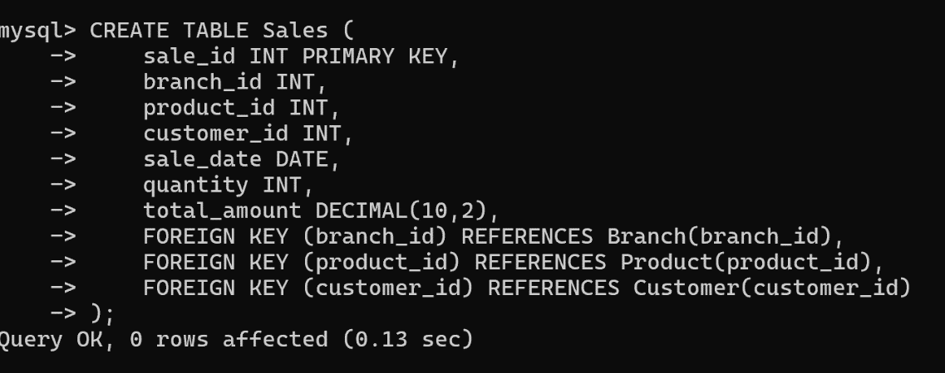

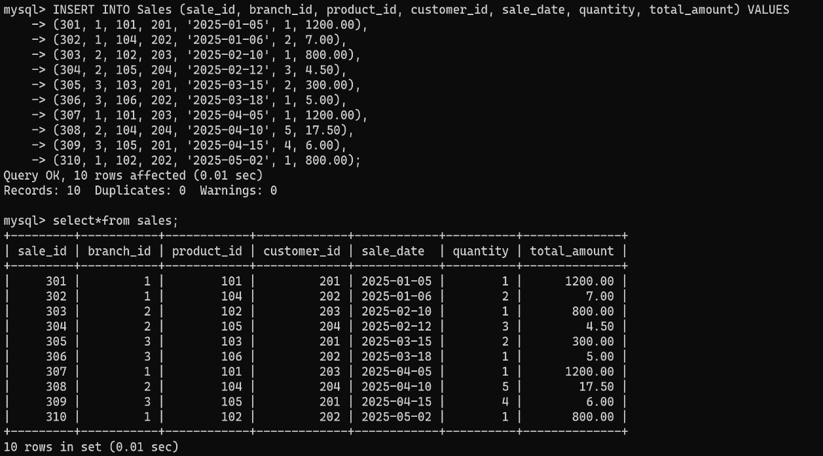

**2. Running Monthly Sales Totals**

* **Tables** : Sales, Branch, Product
  + Sales provides the sale date and total_amount for aggregation.
  + Branch and Product allow grouping per branch and product.
  + SUM() OVER(ORDER BY month) to compute cumulative monthly totals.

**3. Month-over-Month Growth**

* + Sales contains monthly sales totals.
  + Branch and Product allow per-branch and per-product comparisons.
  + LAG() (or LEAD()) to compare the current month with the previous month.
  + 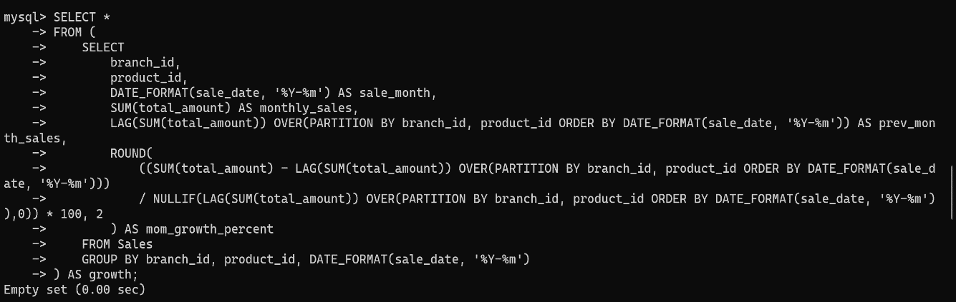

4.Customer quartiles → NTILE(4)

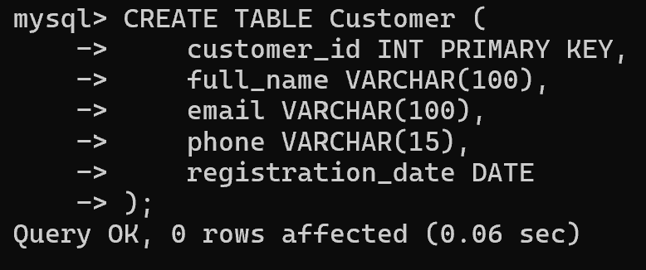

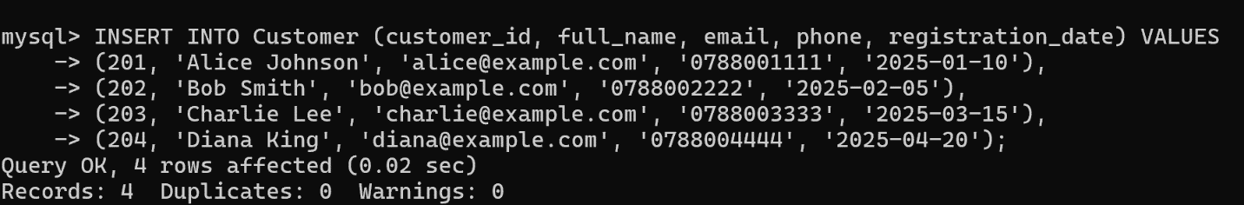

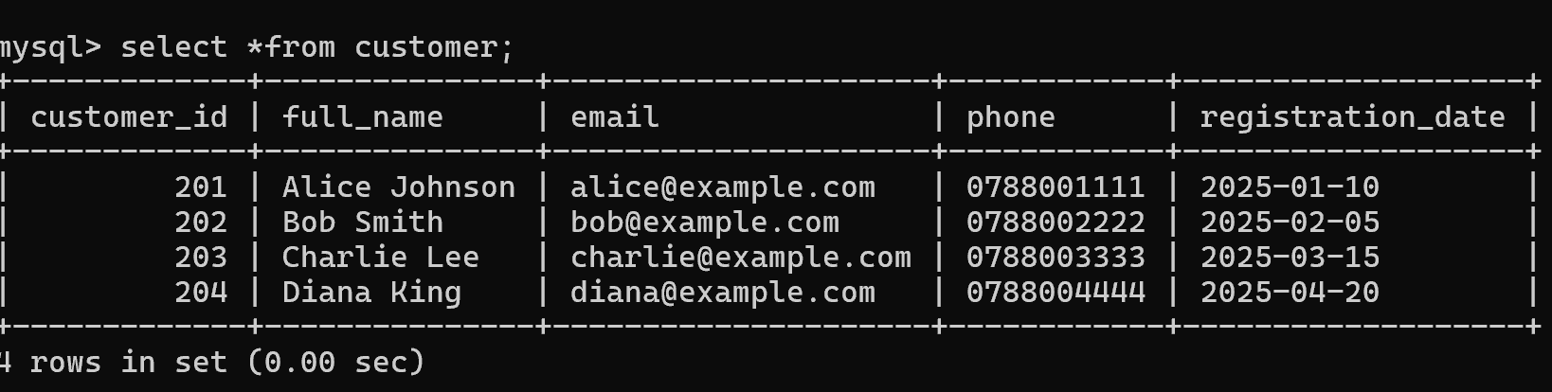

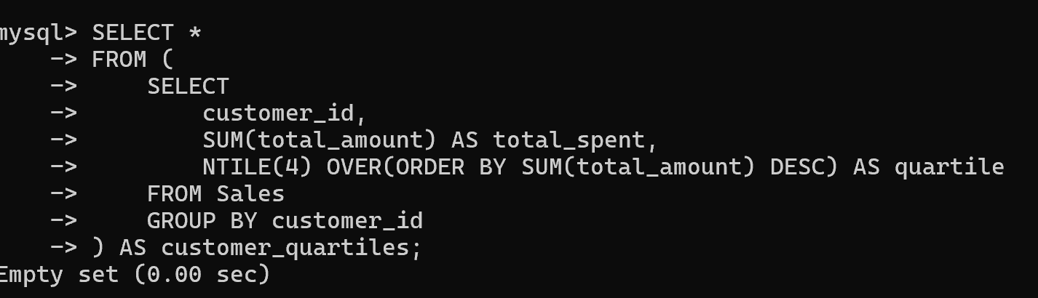

5. 3-month moving averages → AVG() OVER()

AVG() OVER(ORDER BY sale_date ROWS BETWEEN 2 PRECEDING AND CURRENT ROW) to measure short-term trends

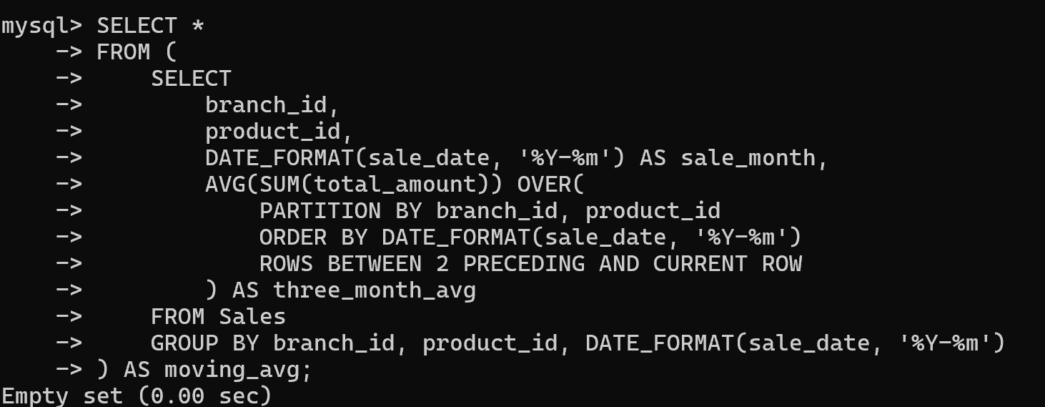

Step3: Database schema

Designing 3 tables ( customers , products & transactions)

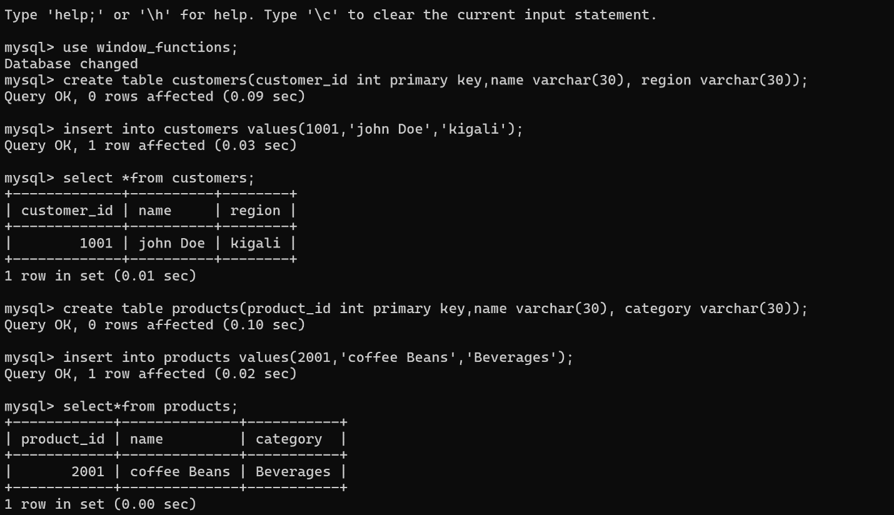

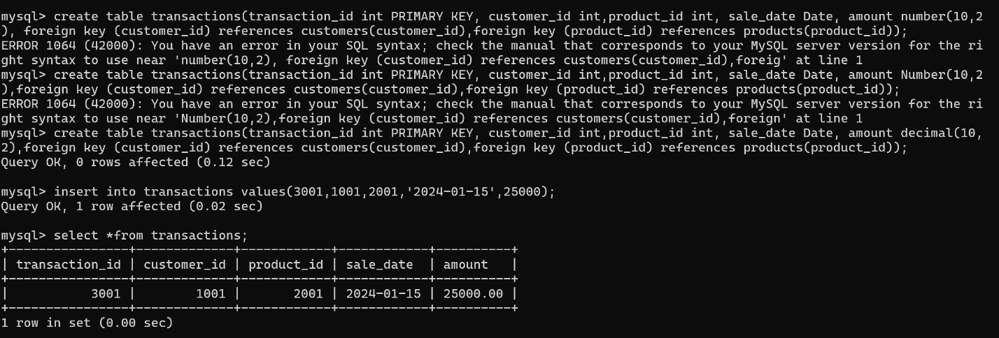

Designing ER diagram

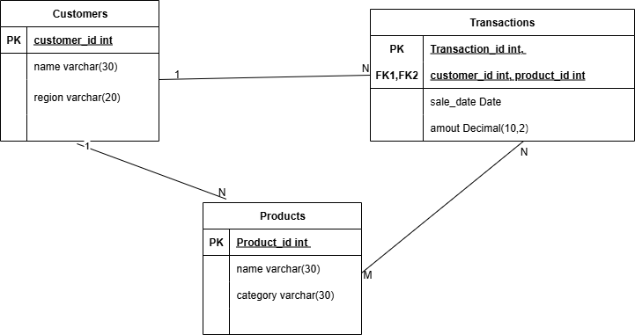

Step4: Window Functions Implementation

1.Ranking function: Top N Customers by Revenue

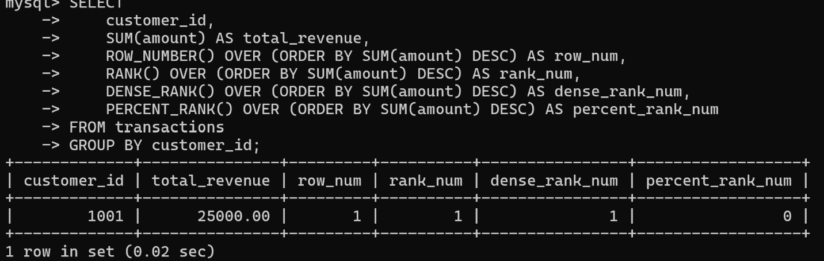

Interpretation: The ranking functions always assign rank on basis of **order by clause, this table is connected to the customers table and** row_number() shows the number of case in customer table,rank() doesn’t accept to double number, dense_rank() assign rank to every rows and percent_rank() makes things by order.

2. Aggregate Functions

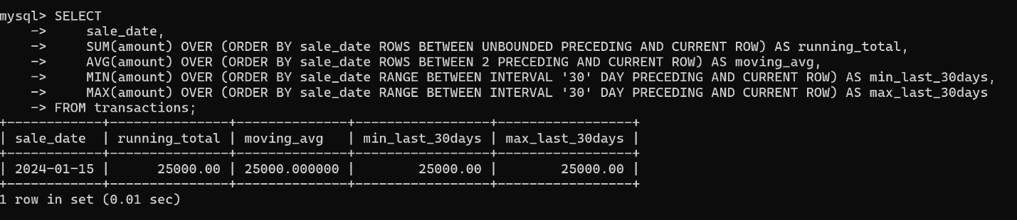

Interpretation: This table is connected to the transactions table, it shows cumulative sales, recent 3-day average, and the lowest and highest sales in the past 30 days for each date.

3. Navigation Functions

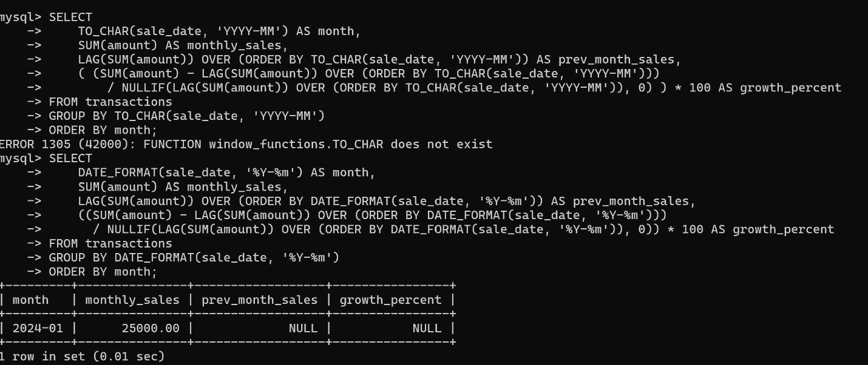

Interpretation: This selection is from transactions table, lag() helped to return value for the previous row, date_format is for the year and month.

4. Distribution Functions

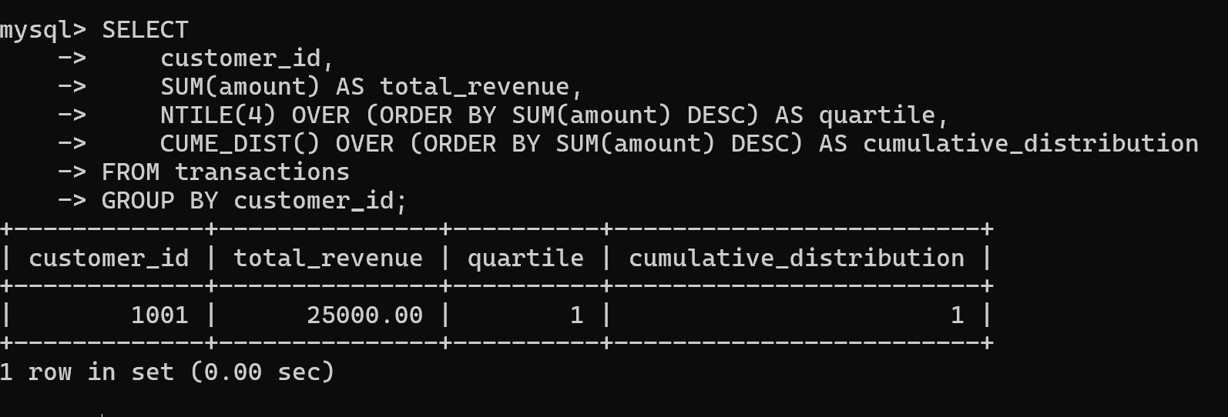

Interpretation: The cume_dist() calculates the cumulative distribution value of each row based on its order in the partition and Ntile() divide customer into quartile(four).

Step6: Result analysis ( Eg.: T2000 market)

Writing insights in 3 layers:

1. **Descriptive (What happened?)**

• Patterns, Trends & outliers: On the weekends there’s more clients (from Friday to Sunday)

Some items finish quickly so you need to restore them. For foods and clothes, we’ve more female client and for electronic things more men than women.

1. **Diagnostic (Why it happened?)**

High return of some articles (for example if it was a wrong command or quality issue, etc.), Younger clients respond better to online discounts and promotions. When some products are expired and still there with low prices.

***3. Prescriptive (What next?)***

* **Recommendations:**
  + Increase stock of high-demand items
  + Promote some months promotions
  + Digital payment
* **Business actions:**
  + Make some collaborations with some people.
  + Apply the online platform
  + Digital marketing (when customers are most likely to engage with your products, on which channel, and their preferences for delivery and returns, you can develop a strong retention strategy.)

Step7: References

.[MySQL | Ranking Functions - GeeksforGeeks](https://www.geeksforgeeks.org/mysql/mysql-ranking-functions/).  
.SQL Window Function | How to write SQL Query using RANK, DENSE RANK, LEAD/LAG | SQL Queries Tutorial

.[How to Write a Market Description: 11 Steps (with Pictures)](https://www.wikihow.com/Write-a-Market-Description)

# Leadership on the Line, With a New Preface: Staying Alive Through the Dangers of Change by [Ronald Heifetz](https://store.hbr.org/shop/?search_query=Ronald%20Heifetz&section=product) and [Marty Linsky](https://store.hbr.org/shop/?search_query=Marty%20Linsky&section=product)